1-Single Instance Launch using Terraform Template

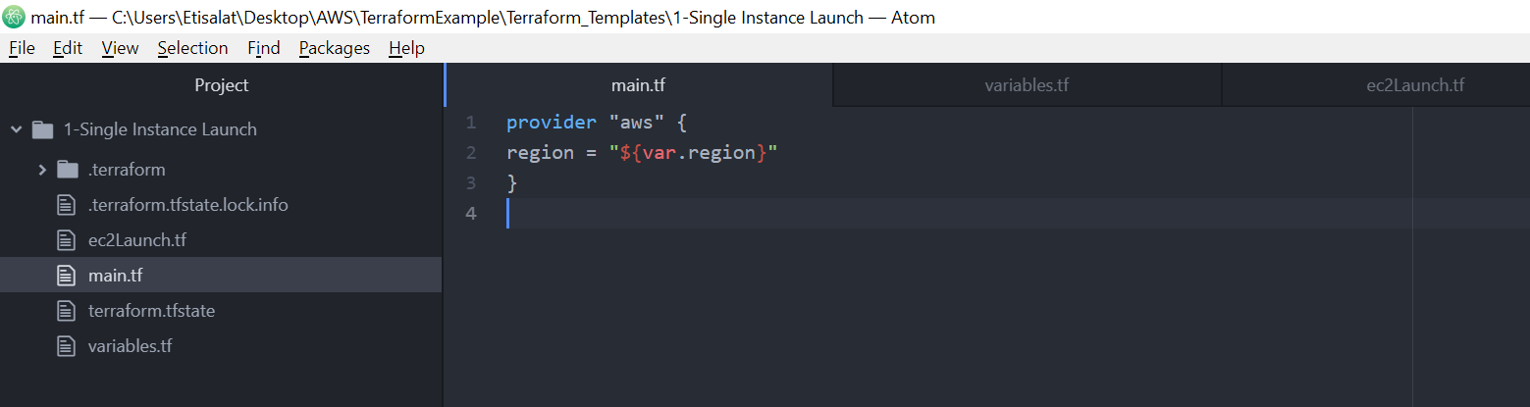

Open AWS console and change the region.

Check the ami image and specify same in variable.tf

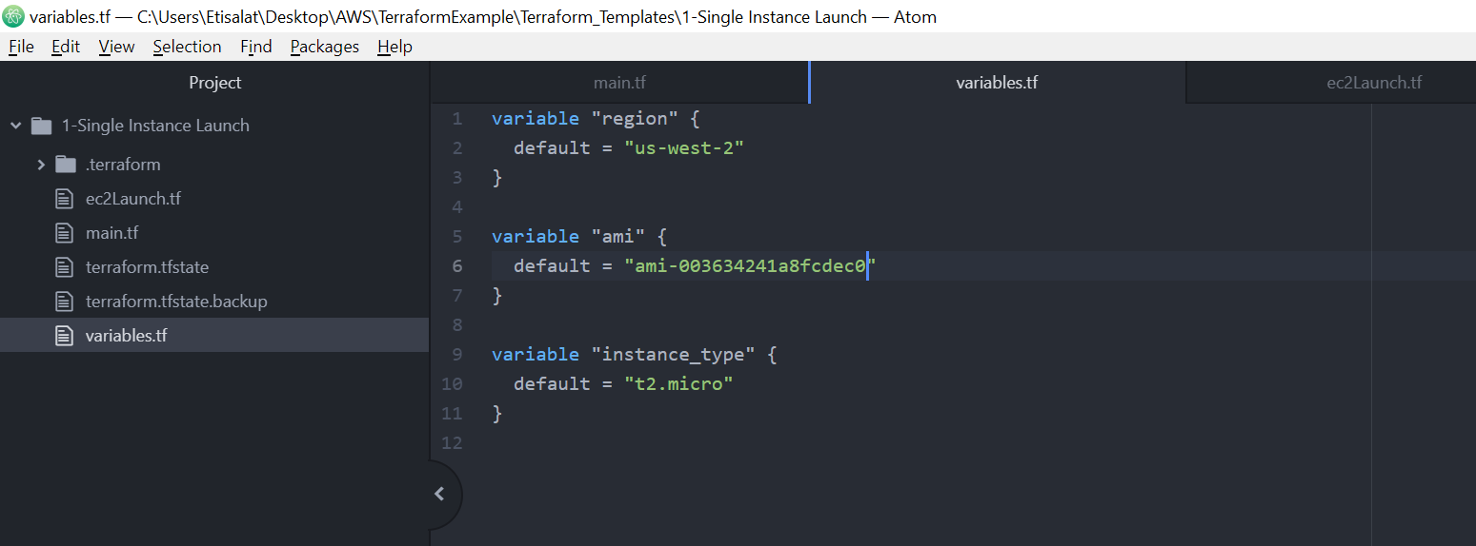

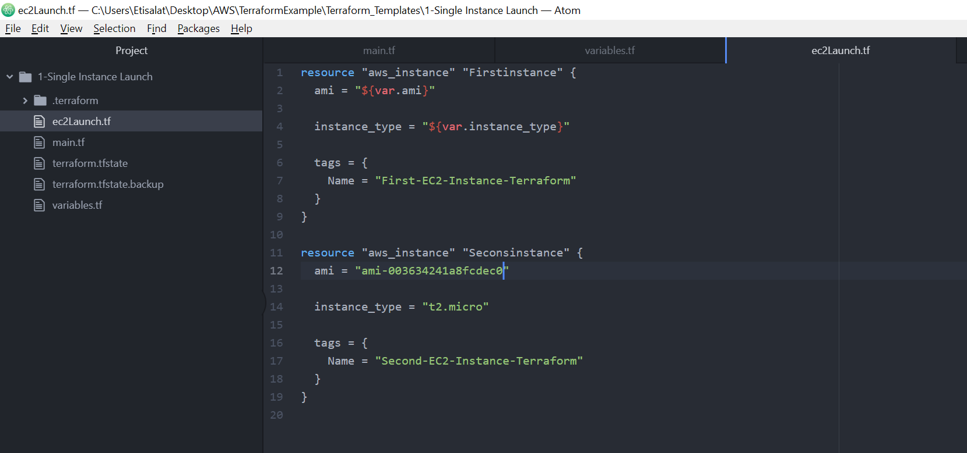

Now, Go to Project folder location and open the CMD line

Run the below command-

1. **Terraform init**
2. **Terraform plan**
3. **Terraform appy –auto-approve**

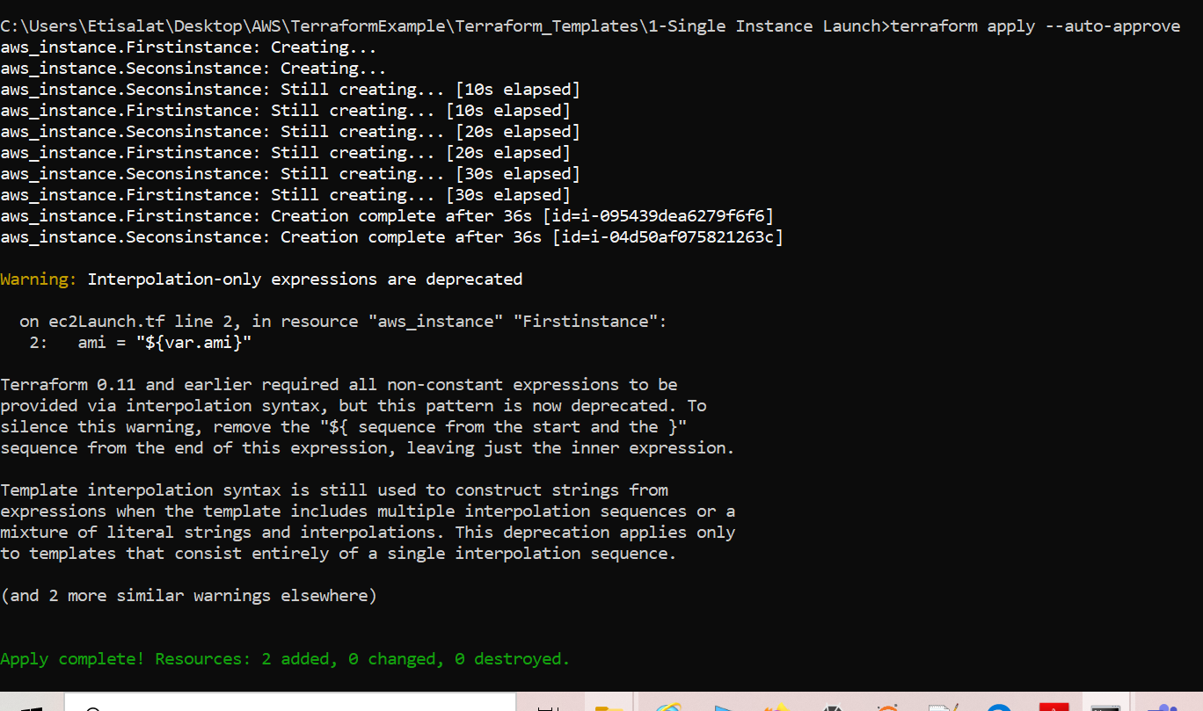

Go to AWS console-

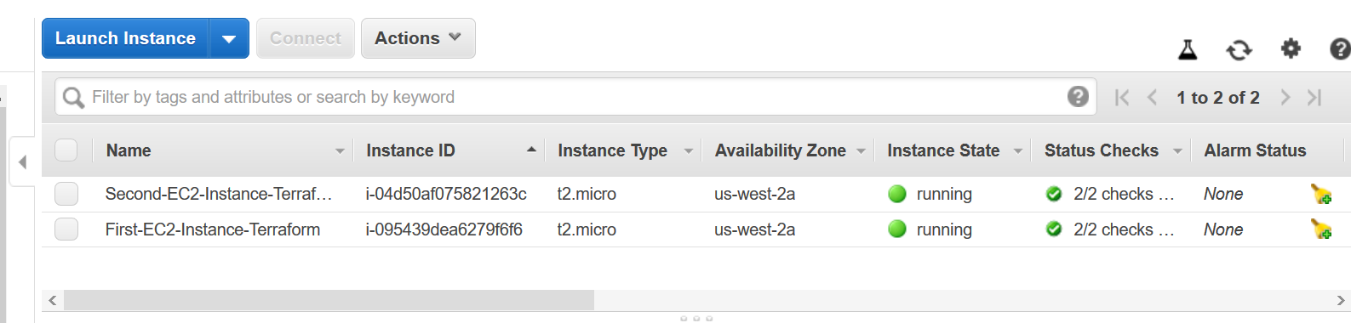

Delete the Resources below command

**Terraform destroy –auto-approve**